**NAME : Chandramohan k**

**ROLL NO :**

**717821P112**

**DATE : 27/2/2023**

**1. Recursion and stack:**

**Week 3:**

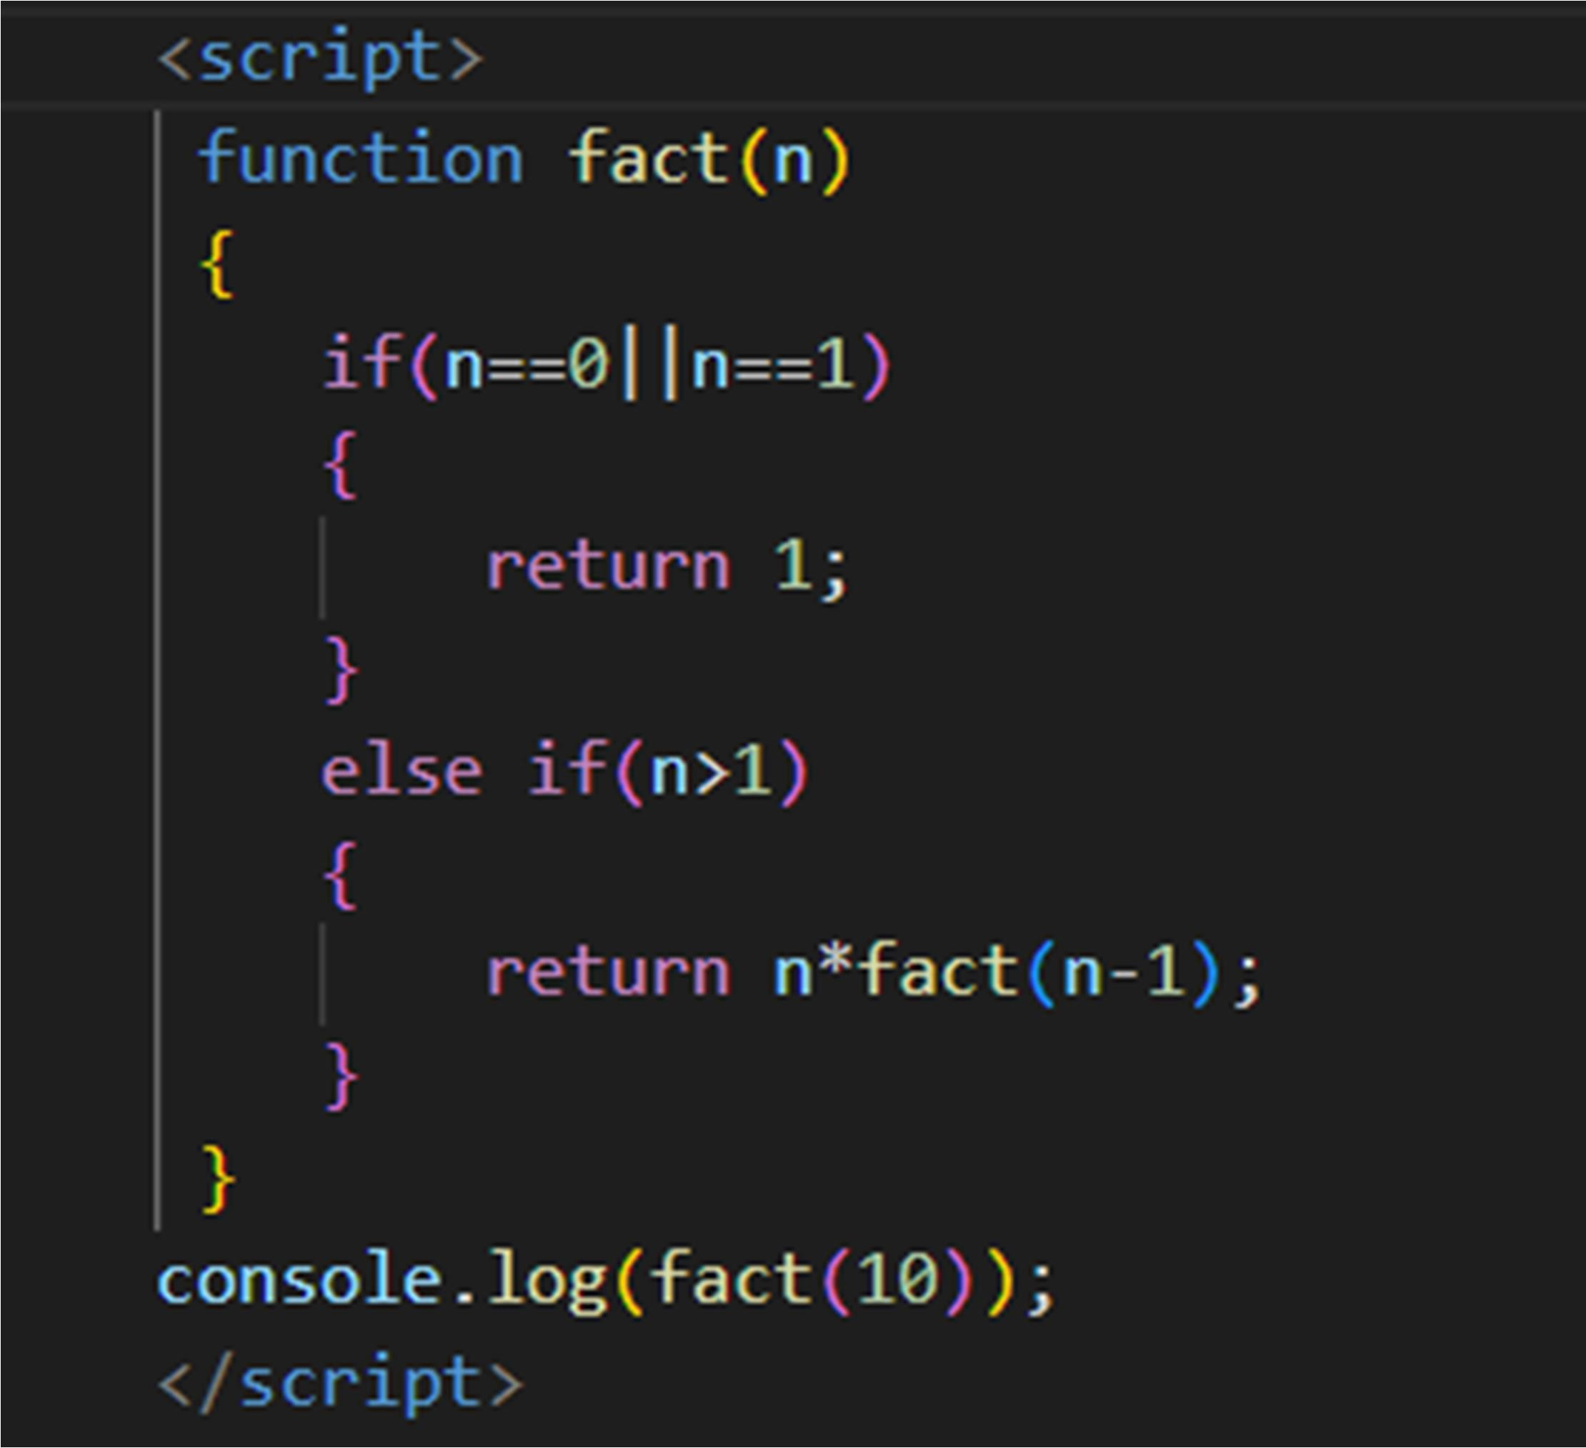Task 1: Implement a function to calculate the factorial of a number using recursion.



Task 2: Write a recursive function to find the nth Fibonacci number.

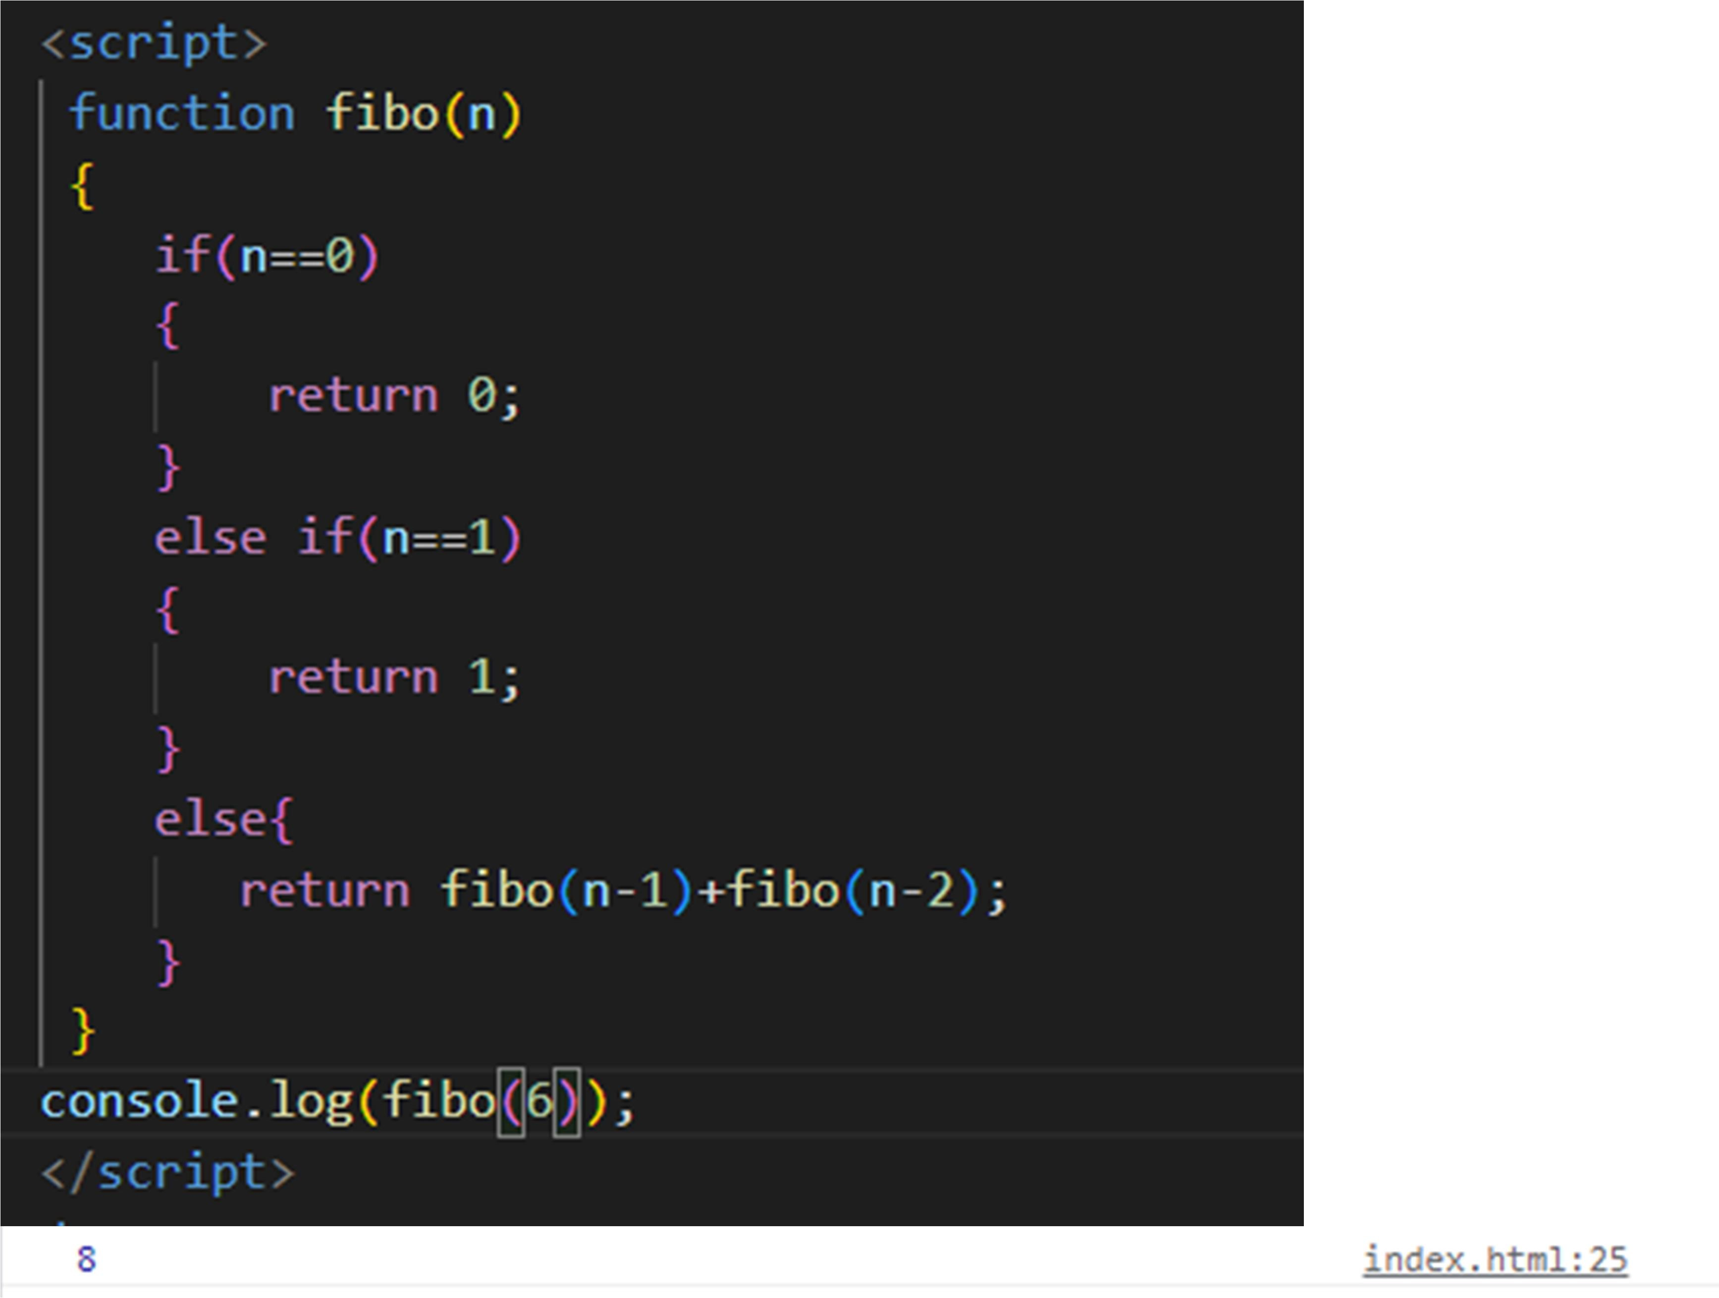

Task 3: Create a function to determine the total number of ways one can climb a staircase with 1, 2, or 3 steps at a time using recursion.

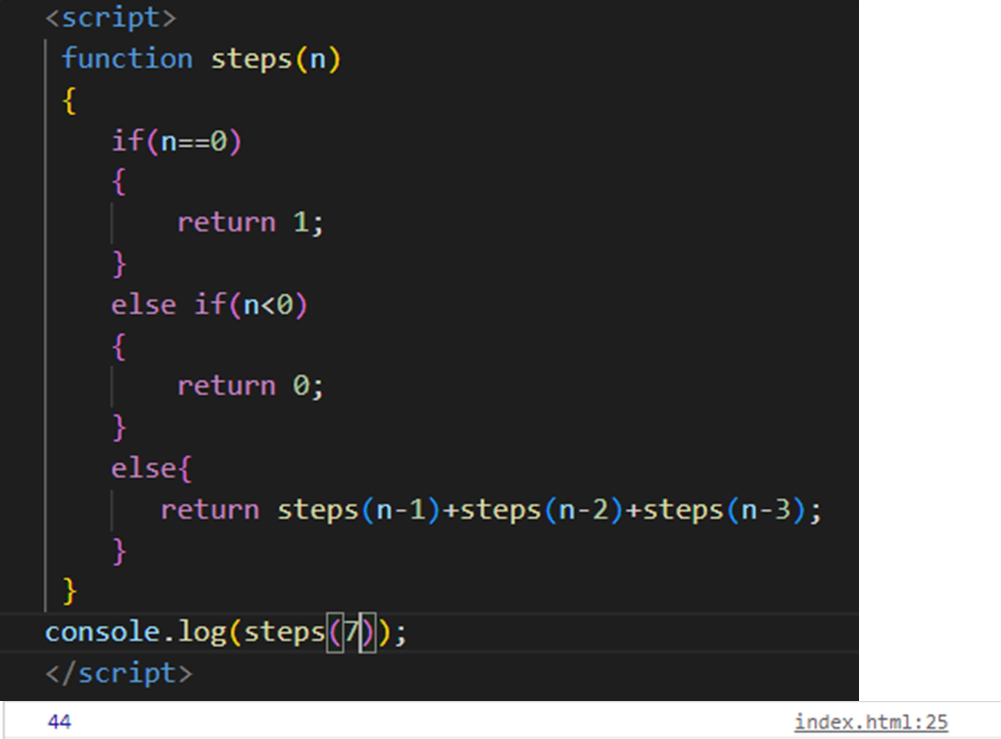

Task 4: Write a recursive function to flatten a nested array structure.

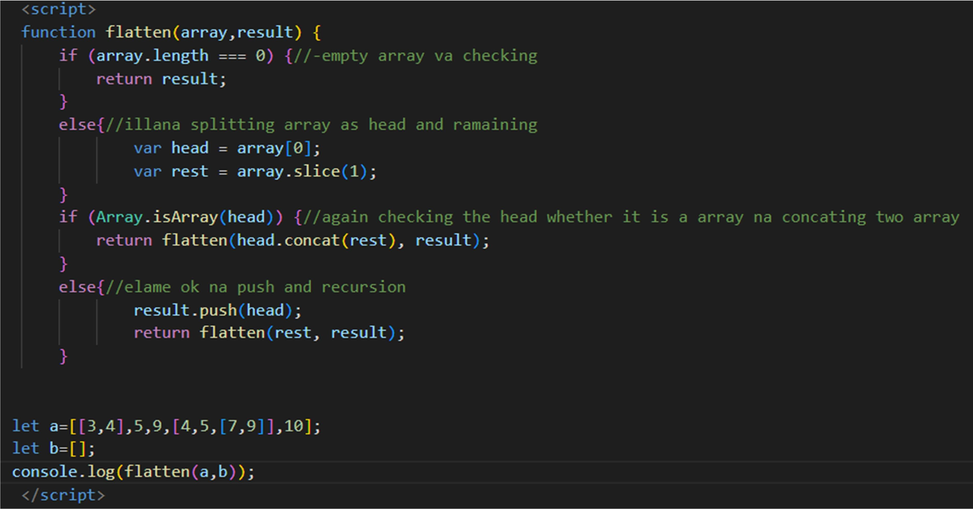

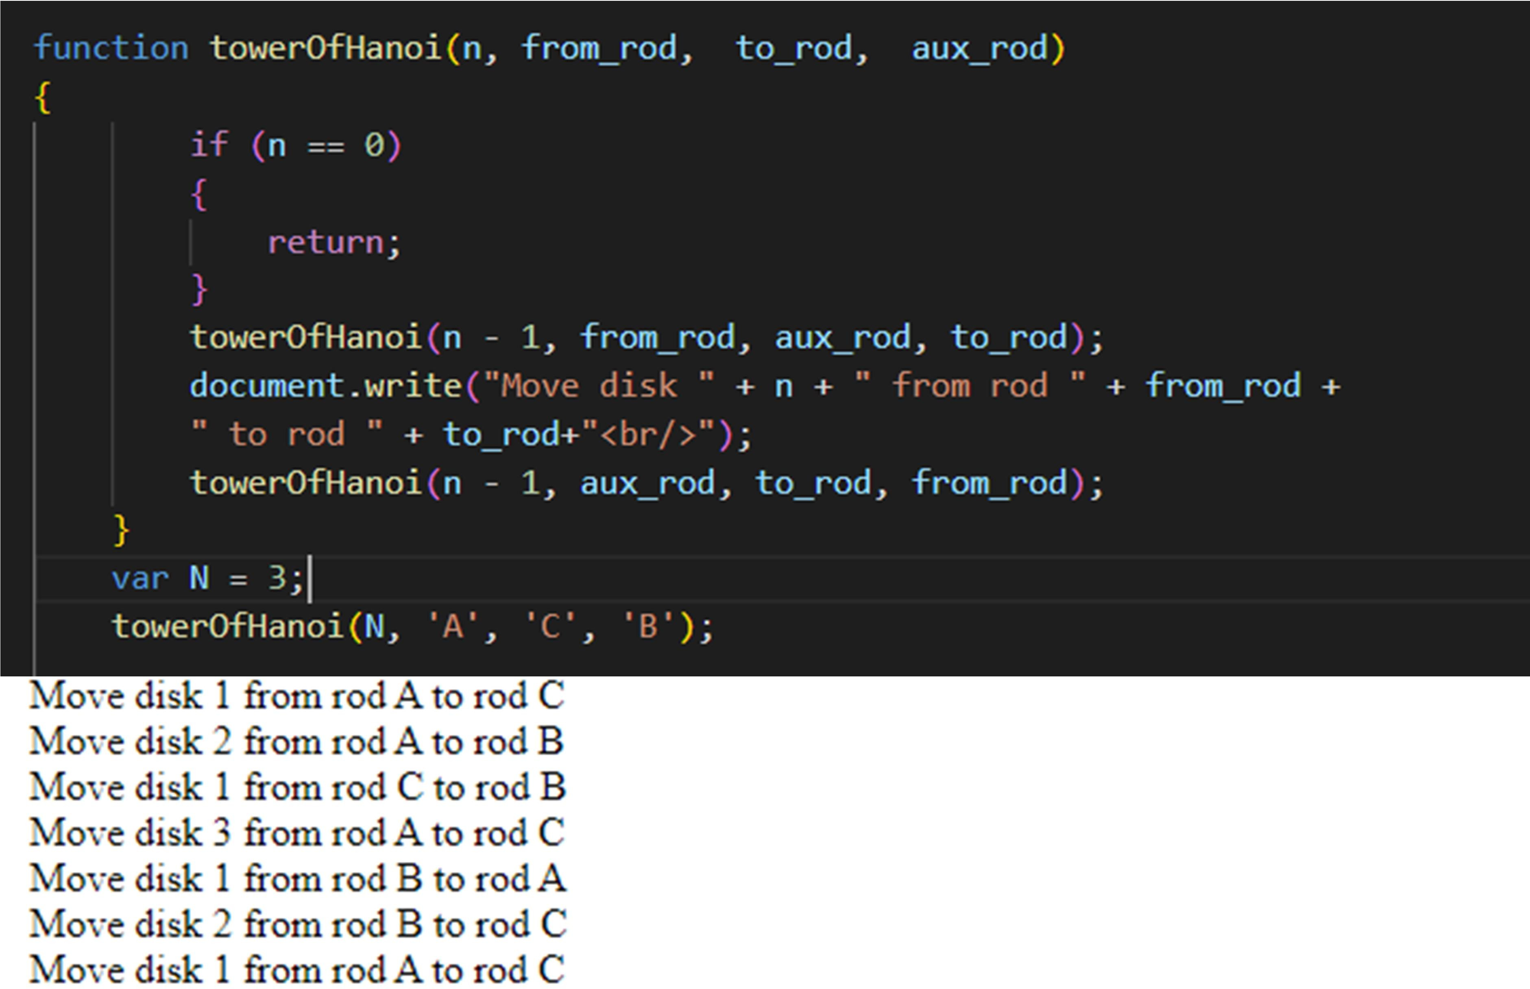Task 5: Implement the recursive Tower of Hanoi solution.